Create Announcement Subscription with ORM Stack

Contents

1. Introduction 1
2. Workflow diagram to deploy the stack 1
3. Create stack for Policies on “Default Domain” 2
4. Plan the Job 15
5. Apply the Job 16
6. Verify in the Console 18
7. Destroy the stack (if required) 18

Introduction

The Announcements service alerts you of operational events that impact service status or your environment. You can subscribe to announcements to receive them by email, SMS, or any other subscription protocol supported through integration with Oracle Cloud Infrastructure Notifications.

Configure an announcement subscription to customize what announcements you want published to the Notifications service. Notifications topics send messages to subscribed endpoints and support multiple subscription protocols

Workflow diagram to deploy the stack

Below diagram shows how the Terraform Artifact are applied in the OCI. While creating a ORM stack, using terraform deliverables Init, Plan and Apply is the flow to provision the resource in the OCI. We can have the deliverables in any of below.
- GitLab/GitHub Repo
- Bitbucket
- Can be in folder/.zip in the local disk
- Object Storage Bucket
- Can be in compartment
- Oracle provided Template


Create stack for Announcement and Subscription

Go to OCI Console Developer Services Resource Manager Stacks select the compartment Create Stack

My Configuration Folder Browse Select the “Announcement” folder that contains the artifacts Upload

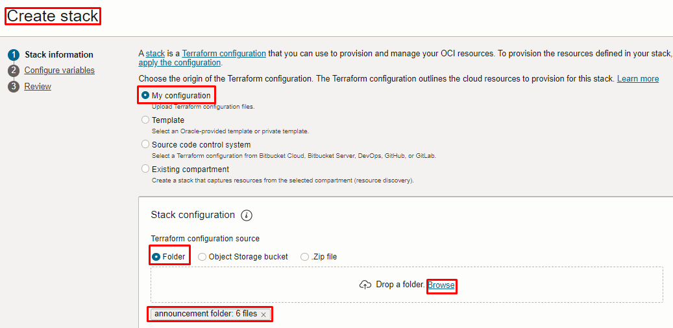
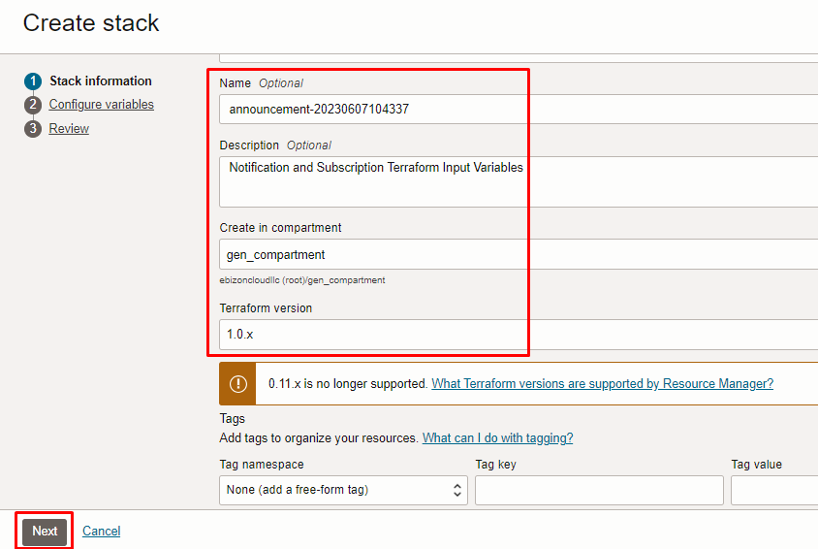

Click “NEXT”

Select the parameters as per the below screen,

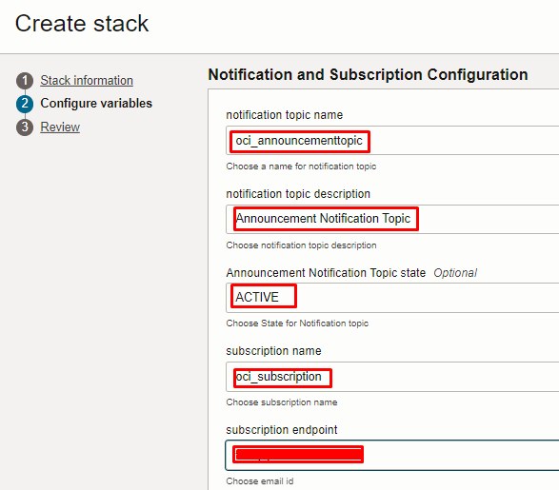
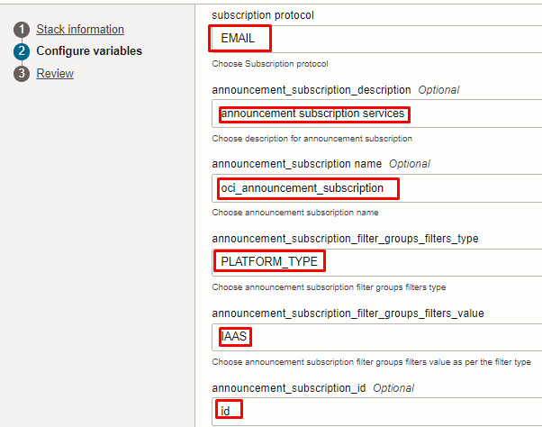

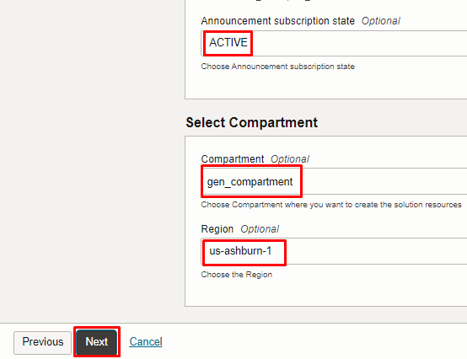

Note: select the right compartment to apply the stack in the OCI

Click “NEXT” Click “CREATE”
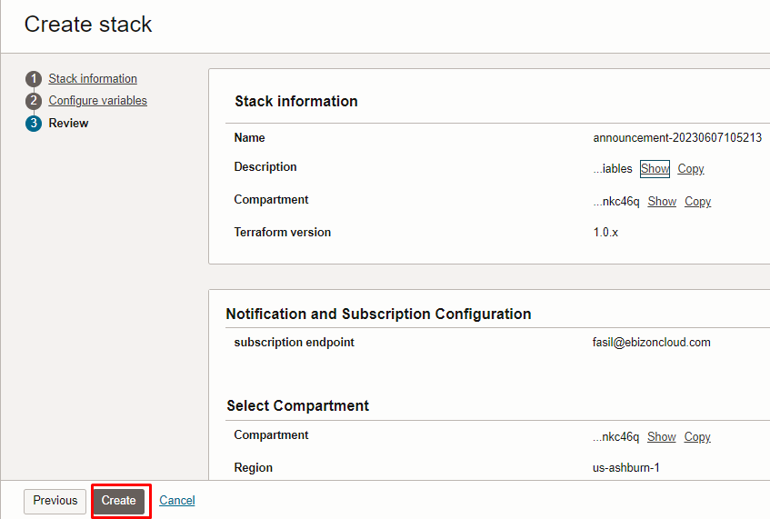

Plan the Job

Click the “Plan”

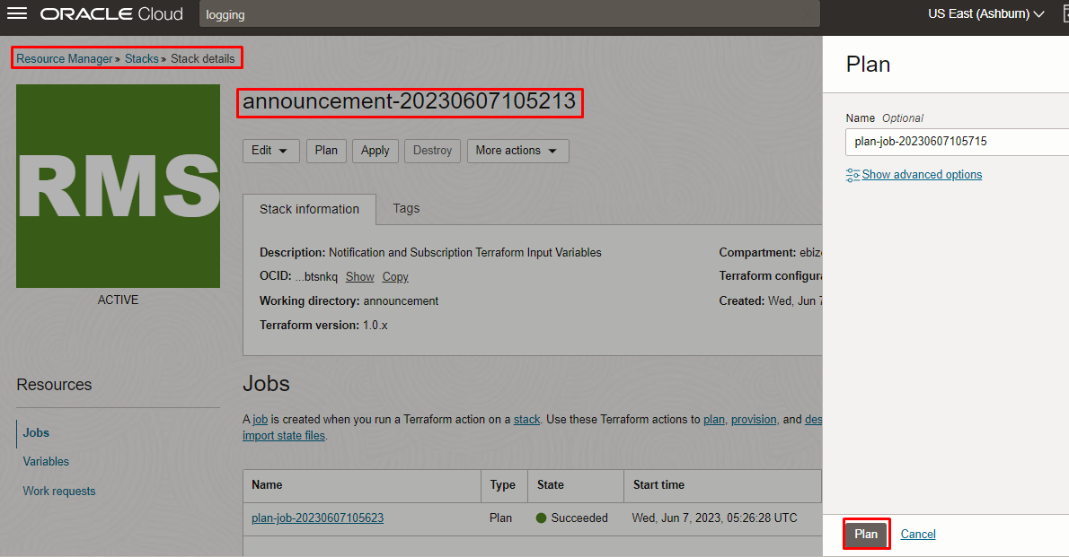

Verify the Plan is successful.

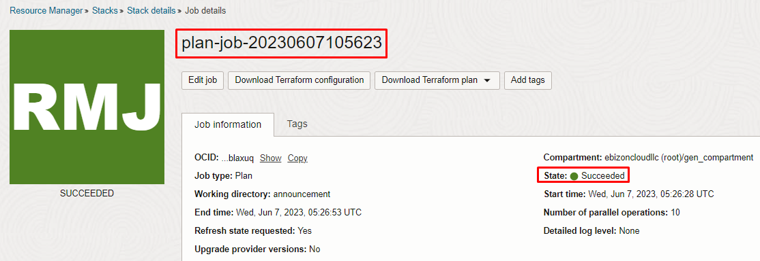
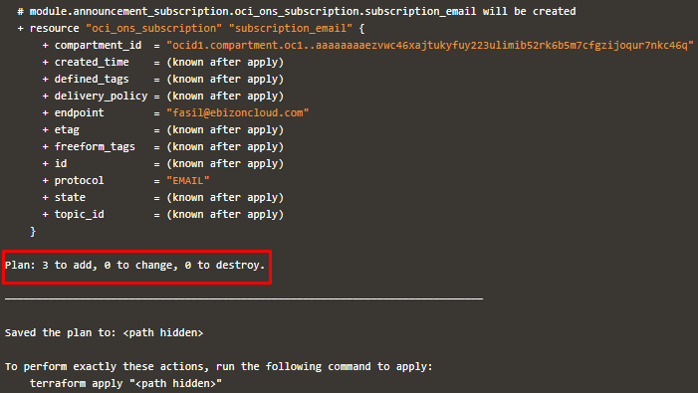

Apply the Job

Once the “plan” is success, now click “Apply”

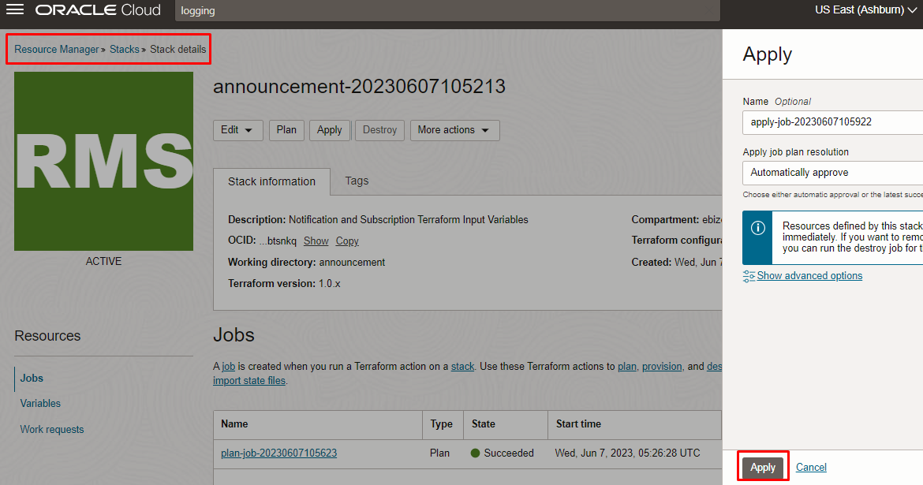

Verify the Apply is successful.

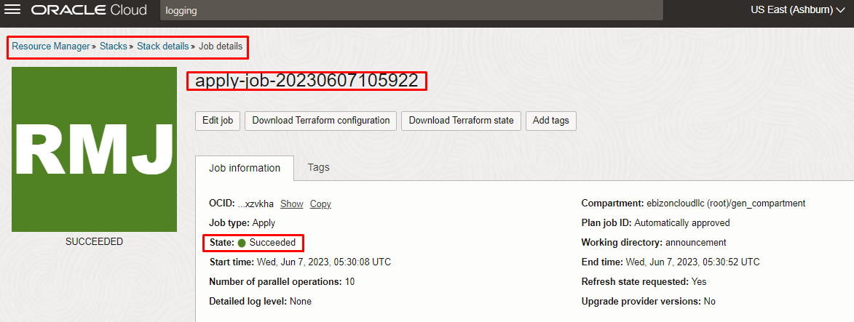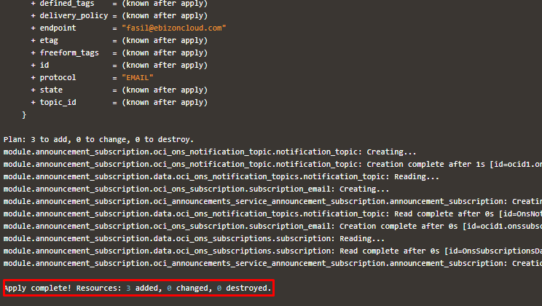

Verify in the Console

Go to OCI Console Identity & Security Policies
Note: Select the specified compartment (in the step 2) to get the output.

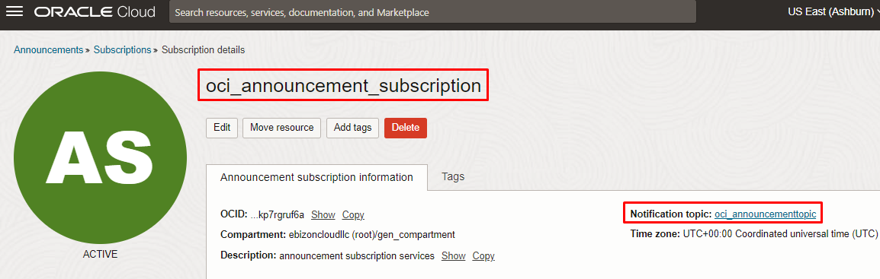
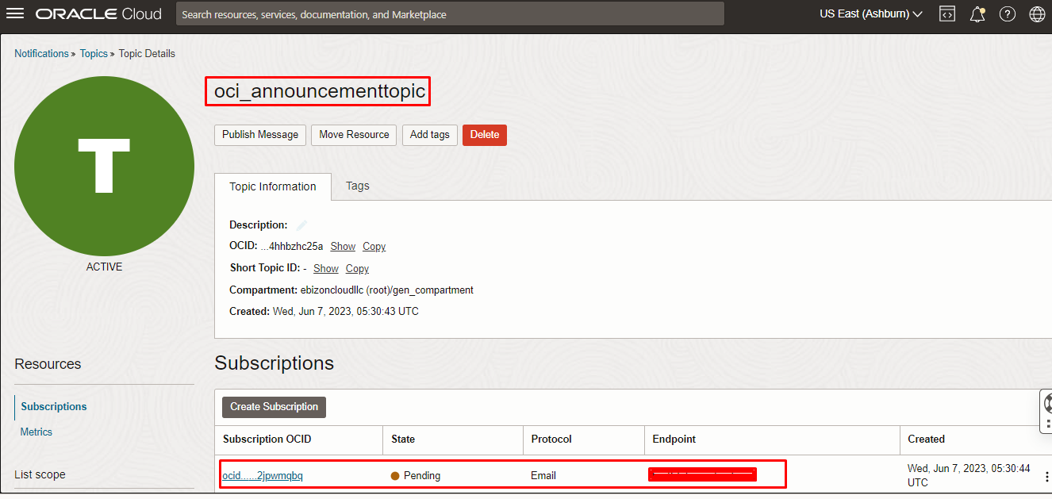

Destroy the stack (if required)

Create a destroy job in Resource Manager to release resources associated with a stack and clean up the tenancy. Once destroyed data cannot be recovered from resources.

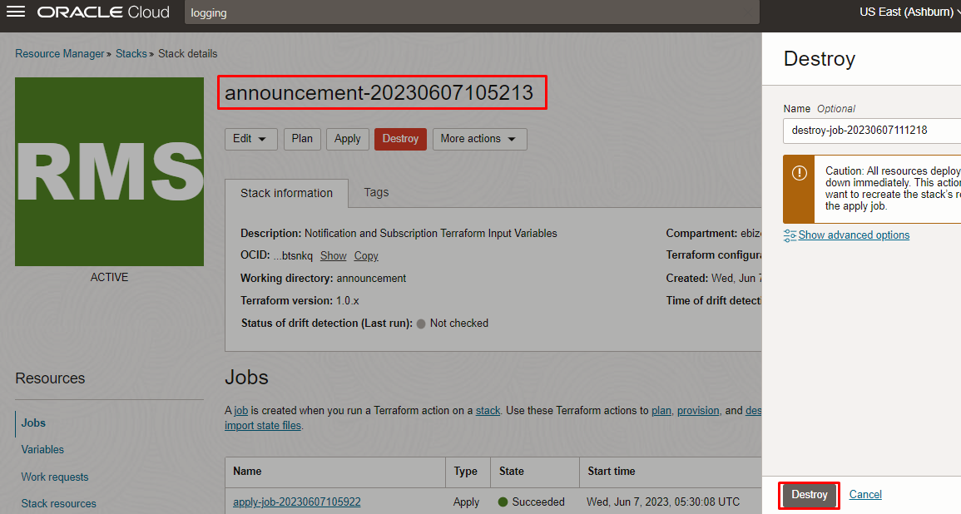

# END #

